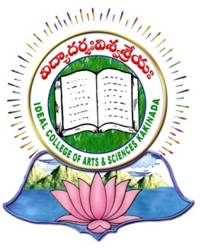 | IDEAL COLLEGE OF ARTS AND SCIENCES (A)
 | (A.P. Govt., Aided., Autonomous & NAAC B++)
 | Dr. P.V.N. RAJU VIDYAPRANGANAM
Samalkot Road, KAKINADA
East Godavari Dist
Andhra Pradesh

Department of English
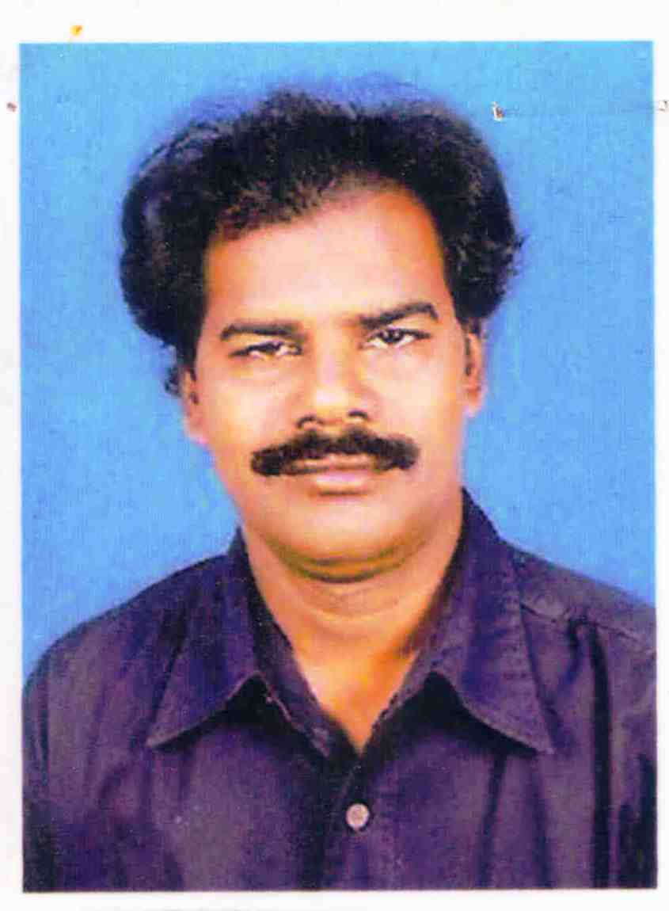

PROFILE

- Name : Kusuma Bala Siddartha Babu
- Designation and Place of work : Sr.Lecturer in English
Ideal College of Arts & Sciences(A)
Kakinada-533004
A.P., INDIA.
- Date of Birth : 20-08-1966
- Nationality : Indian
- Mobile no : 9154012823
- E-mail : siddartha.kusuma1966@gmail.com
- Address for Correspondence : Lecturer in English,
Ideal college of arts & Sciences,
kakinada

- Details of Educational Qualifications:
Sl. No. | Course | University | Year | Specialization
1 | M.A | Andhra university | 1994 | Novel.

- Experience:

Sl. No | Designation | College | Date of Joining | Experience
1 | J.L | Ideal junior college, Kakinada | 21-09-1999 | 08 Years
2 | Lecturer | Ideal college of arts and sciences, Kakinada | 07-02-2007 | 10 Years

- Regional/ State/National level Conferences/Workshops/Seminars

Seminars-3,

